The Archdeacon of Lancaster
The Venerable David Picken

THE ARCHDEACONRY OF LANCASTER
DEANERY OF KIRKHAM
(NB This notice should be displayed prominently on the church notice board on the next Sunday after receiving it)

To the Churchwardens

I hereby give notice that you are requested to attend the Visitation for the Admission of Churchwardens to be held at St Thomas, St Anne’s on Sea, on 13 June at 7.30 pm.
It is essential that those who have been elected to serve as Churchwardens for the year 2023-2024 should be present on this occasion to be sworn in by the Archdeacon of Lancaster and having first been elected by due process.
A form of nomination for Churchwardens, with details of how nominations should be made, together with details of those who are excluded from election, are provided on the Diocesan website, www.blackburn.anglican.org/Archdeacons pages. Please print this notice as appropriate.
If you are unable to attend this visitation, please advise gillian.beeley@blackburn.anglican.org.
31 March 2023
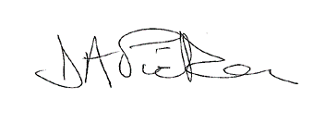
Ven David Picken
Archdeacon of Lancaster

